Stock Market Trend Analysis (Equity Data)
1. Objective
To analyze historical stock price data of multiple Indian companies in order to identify trends, compute technical indicators, and forecast short-term price movements using time series modelling.

2. Problem Statement
Financial markets generate large volumes of time-series data. The goal is to:
- Extract meaningful insights from stock price movements
- Identify trends using technical indicators
- Build a predictive model to forecast future prices
- Present results through an interactive dashboard

3. Literature Survey
Stock market analysis uses historical equity data to understand price behavior and predict future trends. In this project, OHLC data (Open, High, Low, Close) was used, as it gives a complete daily picture of stock movement. Technical indicators such as Moving Average and Rolling Average help identify overall market trends by smoothing short-term fluctuations, while RSI (Relative Strength Index) is used to understand whether a stock may be overbought or oversold. Volatility is another important factor that measures how much stock prices move, helping in risk analysis. Candlestick charts are widely used because they visually represent daily OHLC data and make trends easier to understand.
For prediction, time-series models are commonly used in financial analytics. ARIMA is a statistical forecasting model that predicts future prices using past historical patterns. By combining data collection, visualization, technical indicators, and predictive models, this project creates a complete stock analytics pipeline that helps in understanding market trends and future price movement.

4. Dataset Description
- Source: Yahoo Finance (via yfinance API)
- Stocks Used:
  - RELIANCE.NS
  - TCS.NS
  - INFY.NS
  - HDFCBANK.NS
  - ICICIBANK.NS
  - SBIN.NS
- Data Type:
  - Daily OHLC (Open, High, Low, Close)
- Time Range:
  - 2020 to latest available date

5. System Architecture / Design
Pipeline:
Data Source → Data Ingestion → Preprocessing → Feature Engineering → Modelling → Evaluation → Visualization → Dashboard
Modules:
- data_loader.py → fetch stock data
- preprocessing.py → clean & structure data
- indicators.py → compute technical indicators
- model.py → ARIMA forecasting
- visualization.py → generate charts
- dashboard/app.py → interactive dashboard

6. Methodology
Data Collection
- Used yfinance API to fetch OHLC data
- Stored raw data in CSV format
Data Preprocessing
- Converted date formats
- Sorted time series
- Handled missing values
Feature Engineering
- Simple Moving Average (SMA 20, SMA 50)
- Relative Strength Index (RSI)
- Daily Returns
- Rolling Volatility
Modelling
- Applied ARIMA model for time-series forecasting
- Generated 30-day forecast for each stock
Evaluation
- Visual validation of forecast trends
- Checked consistency with historical movement

7. Results & Outputs
- Cleaned datasets (CSV)
- Feature-engineered datasets
- Forecast outputs (CSV)
- Saved ARIMA models (.pkl)
- Interactive HTML charts

8. Visualizations
- Candlestick charts with moving averages
- RSI and volatility plots
- Forecast overlay charts
- Dashboard interface

9. Tools Used
- Python
  - pandas, numpy
  - yfinance
  - statsmodels (ARIMA)
  - plotly
  - dash
- Exploratory Data Analysis (performed using Python scripts and visualizations)

10. GitHub Repository Link
https://github.com/piyush-nandre/Stock-Trend-Analysis-Equity-Data/
11. Screenshots
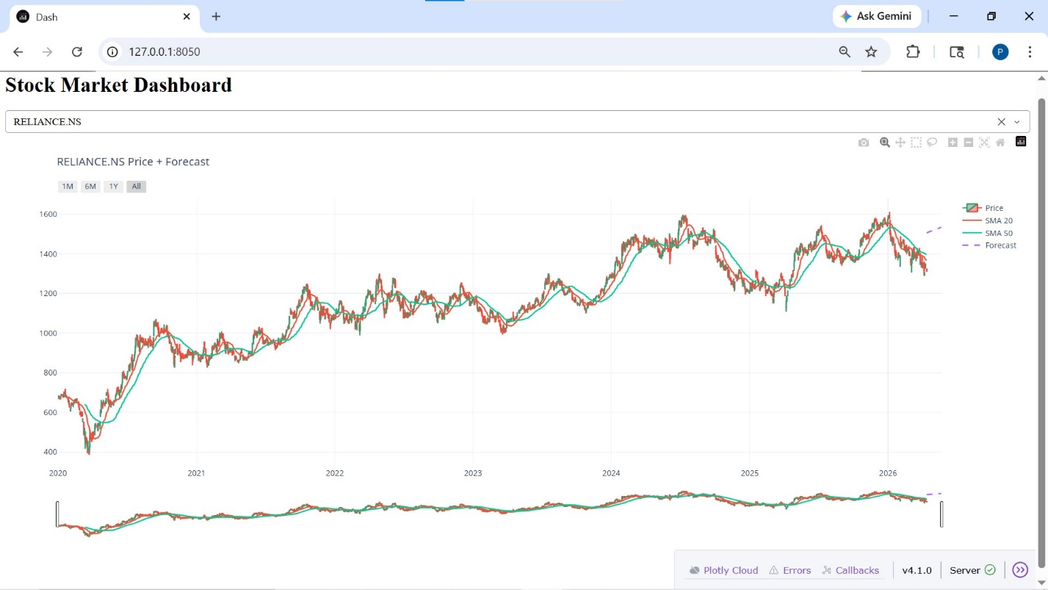
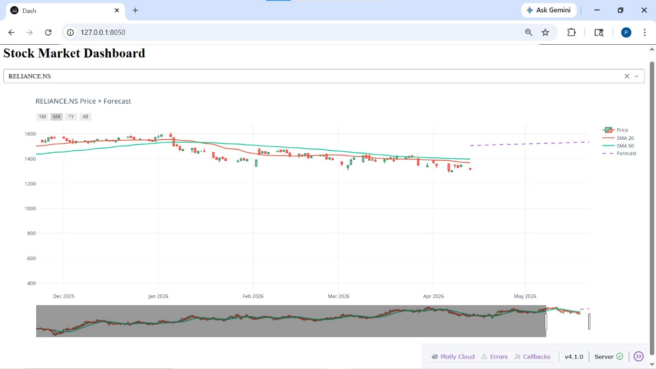
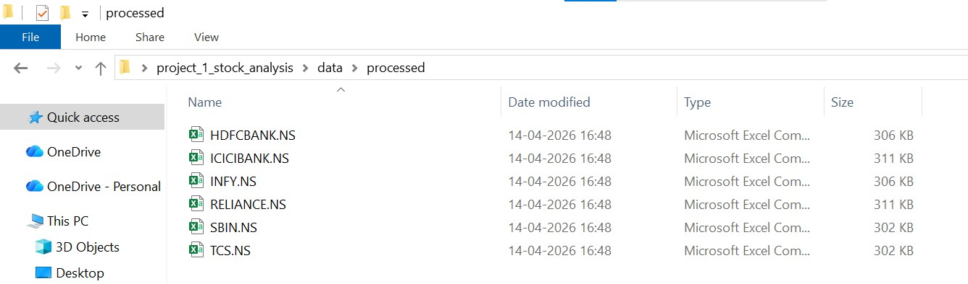
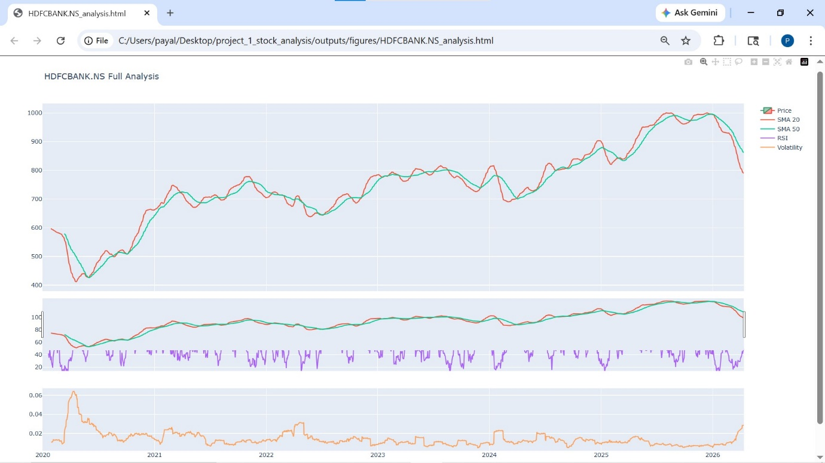
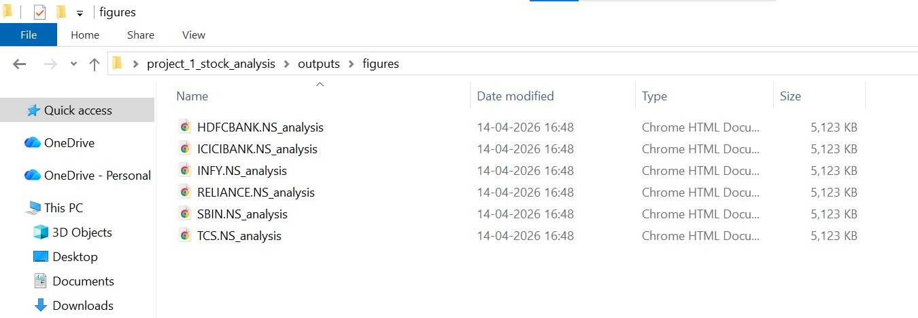
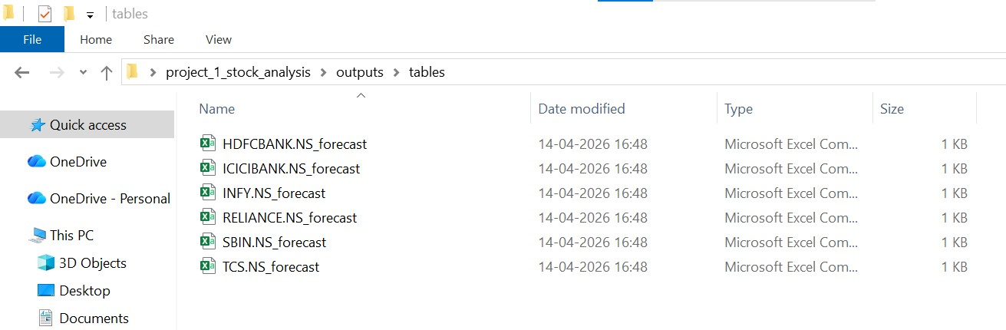
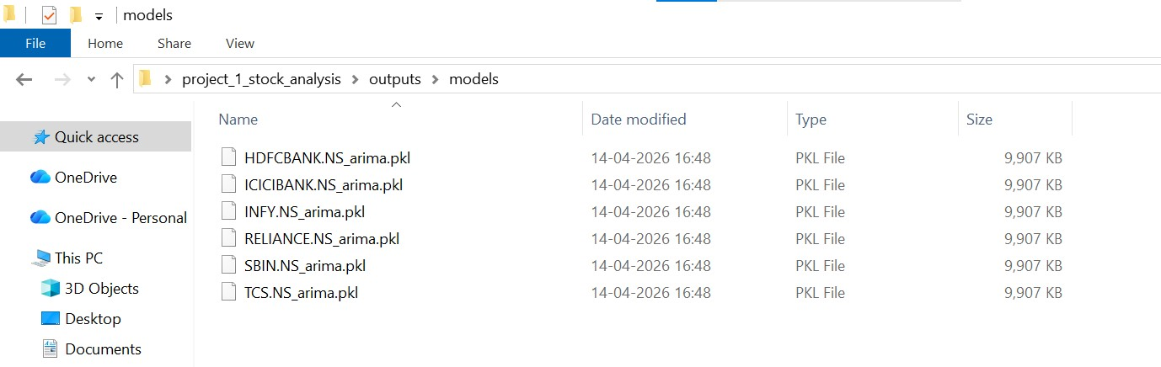

12. Demo Video Link
https://youtu.be/K-DYXKYPlDw/
13. Key Insights
- Moving averages helped identify trend direction
- RSI indicated overbought/oversold conditions
- Volatility highlighted risk periods
- ARIMA provided reasonable short-term forecasts

14. Conclusion
The project successfully demonstrated an end-to-end financial analytics pipeline. It integrated data collection, feature engineering, time-series modeling, and interactive visualization into a cohesive system.

